EEE 120
Lab 4 Answer Sheet
The Complete Microprocessor
Name: Dylan Shah
Instructor/Time: Dr. Steve Millman Tu Th 3:00 PM - 4:15 PM Date: March 26, 2026
Task 4-1: Build and Test the Memory-Address-Generation Circuit
Include a picture of your Digital circuit here:
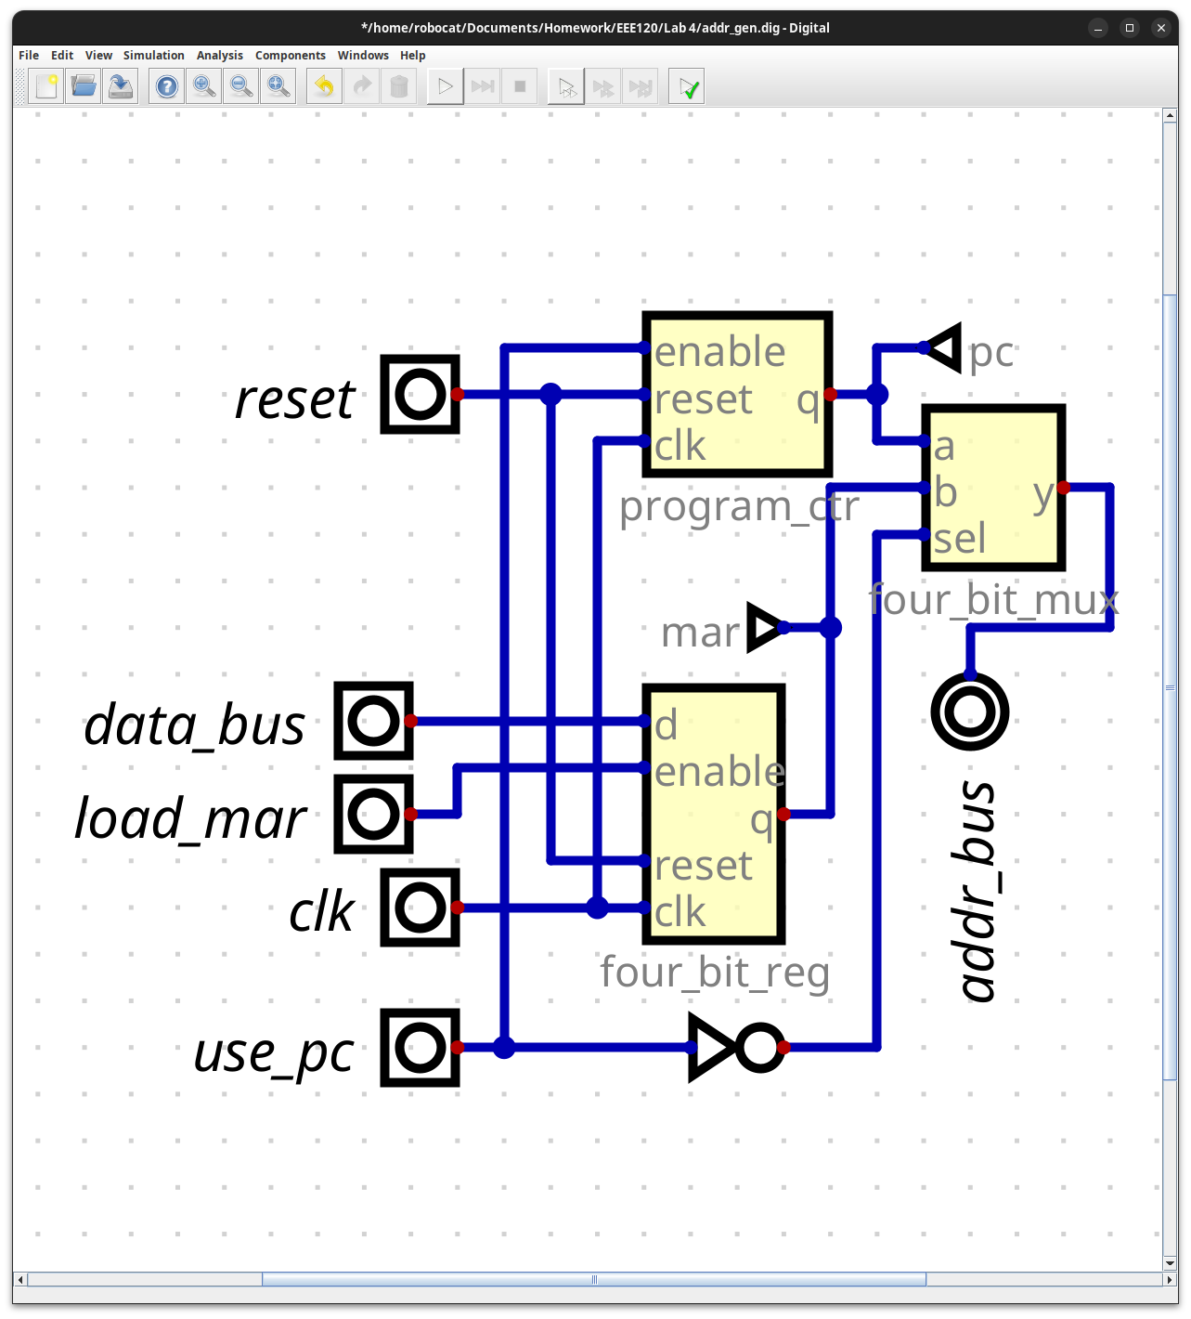
Please comment on the single biggest issue you were facing when designing the circuit.
I did not have any issues designing the circuit.
Did the circuit behave as expected? If no, what was wrong?
Yes the circuit behaved as I expected.
Please comment on the single biggest issue you were facing when simulating the circuit.
I did not realize that the pc should not count when it was disabled, and then I spent a minute trying to look for what was wrong before realizing that it was correct.
Task 4-2: Build and Test the Controller Circuit
Include a picture of your two_bit_bus_mux circuit here:
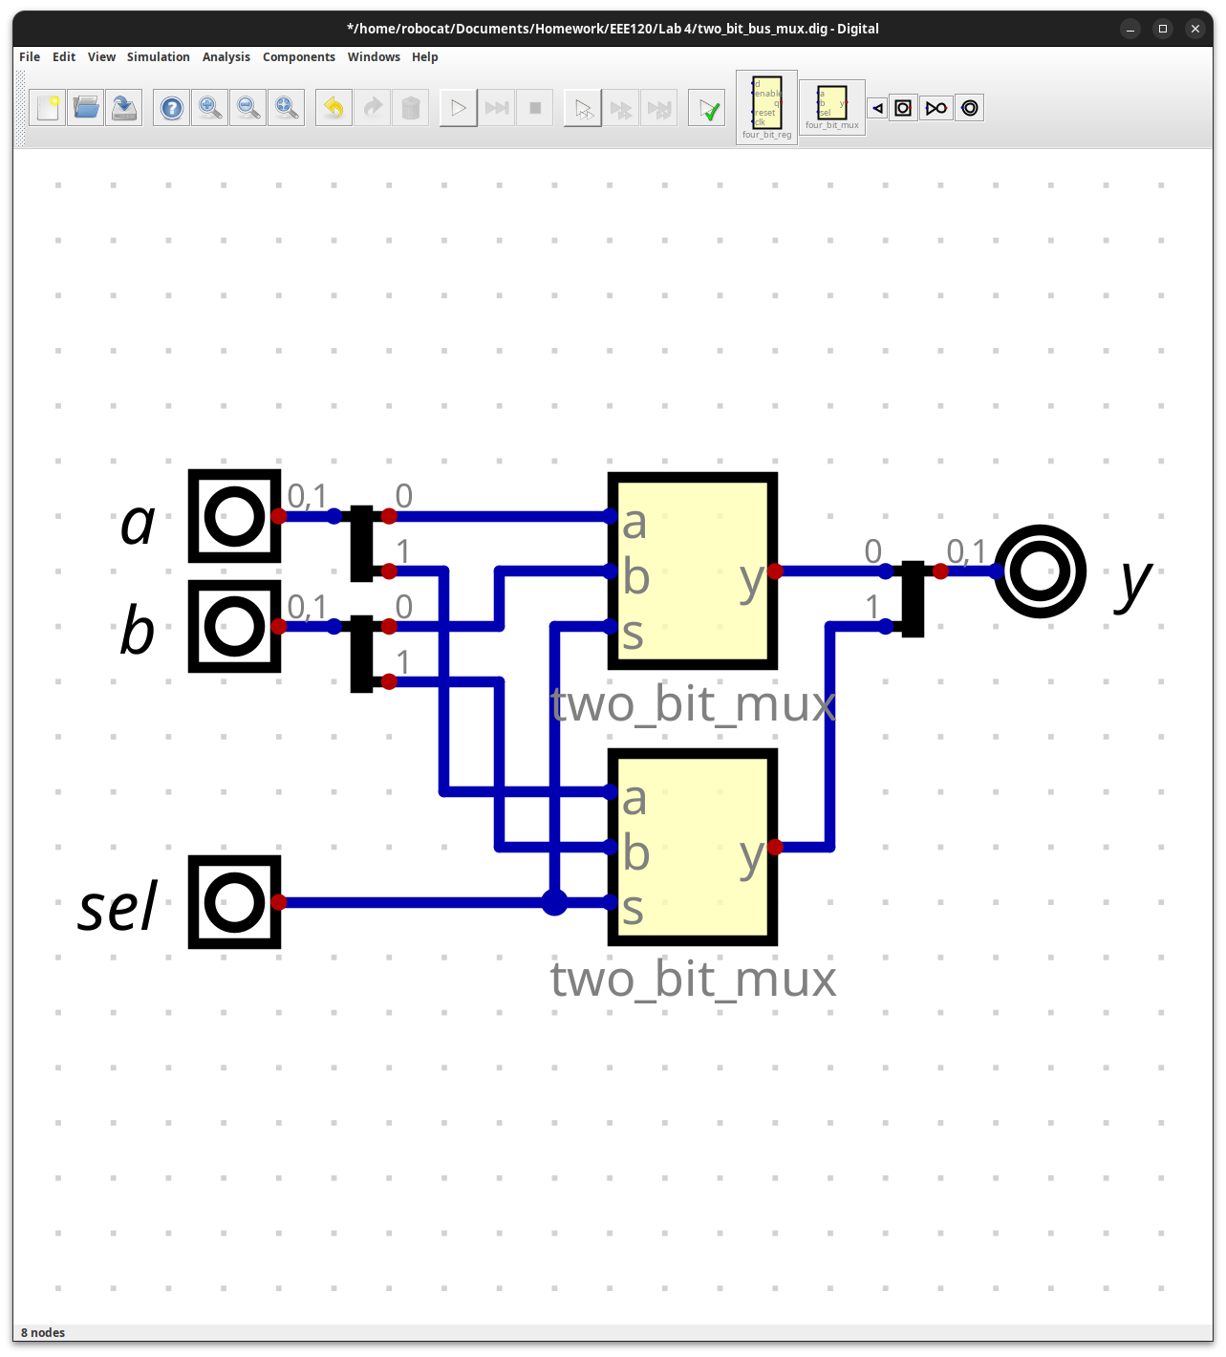
Please comment on the single biggest issue you were facing when designing the circuit.
There were no issues designing the circuit.
Did the circuit behave as expected? If no, what was wrong?
Yes, the circuit behaved as I expected.
Please comment on the single biggest issue you were facing when simulating the circuit.
I did not experience any issues simulating the circuit.
Include a picture of your two_bit_reg circuit here:
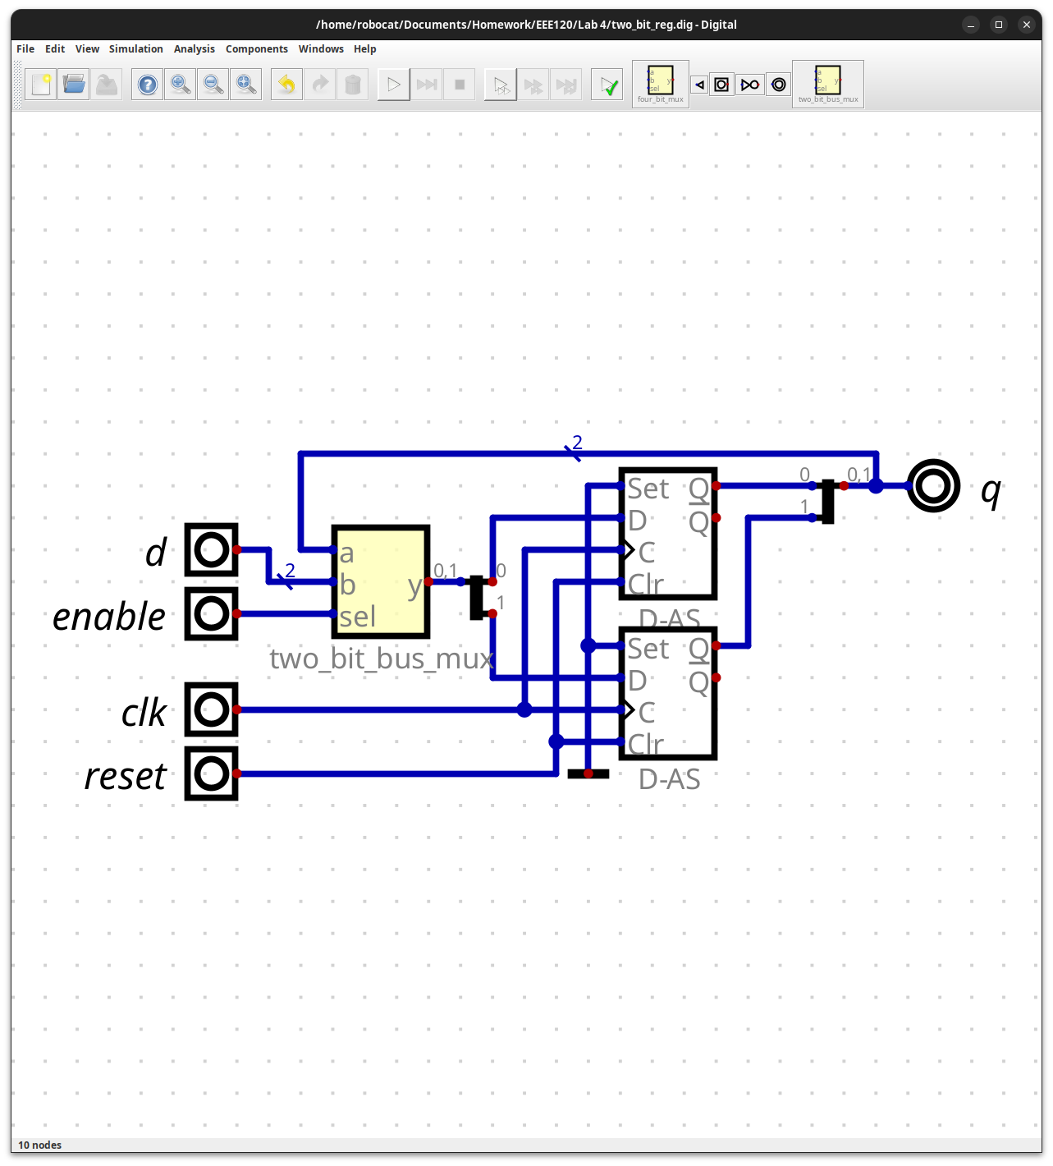
Please comment on the single biggest issue you were facing when designing the circuit.
I did not have any issues designing the circuit.
Did the circuit behave as expected? If no, what was wrong?
Yes, the circuit worked as I expected.
Please comment on the single biggest issue you were facing when simulating the circuit.
I did not run into any issues simulating the circuit.
Include a picture of your controller circuit here:
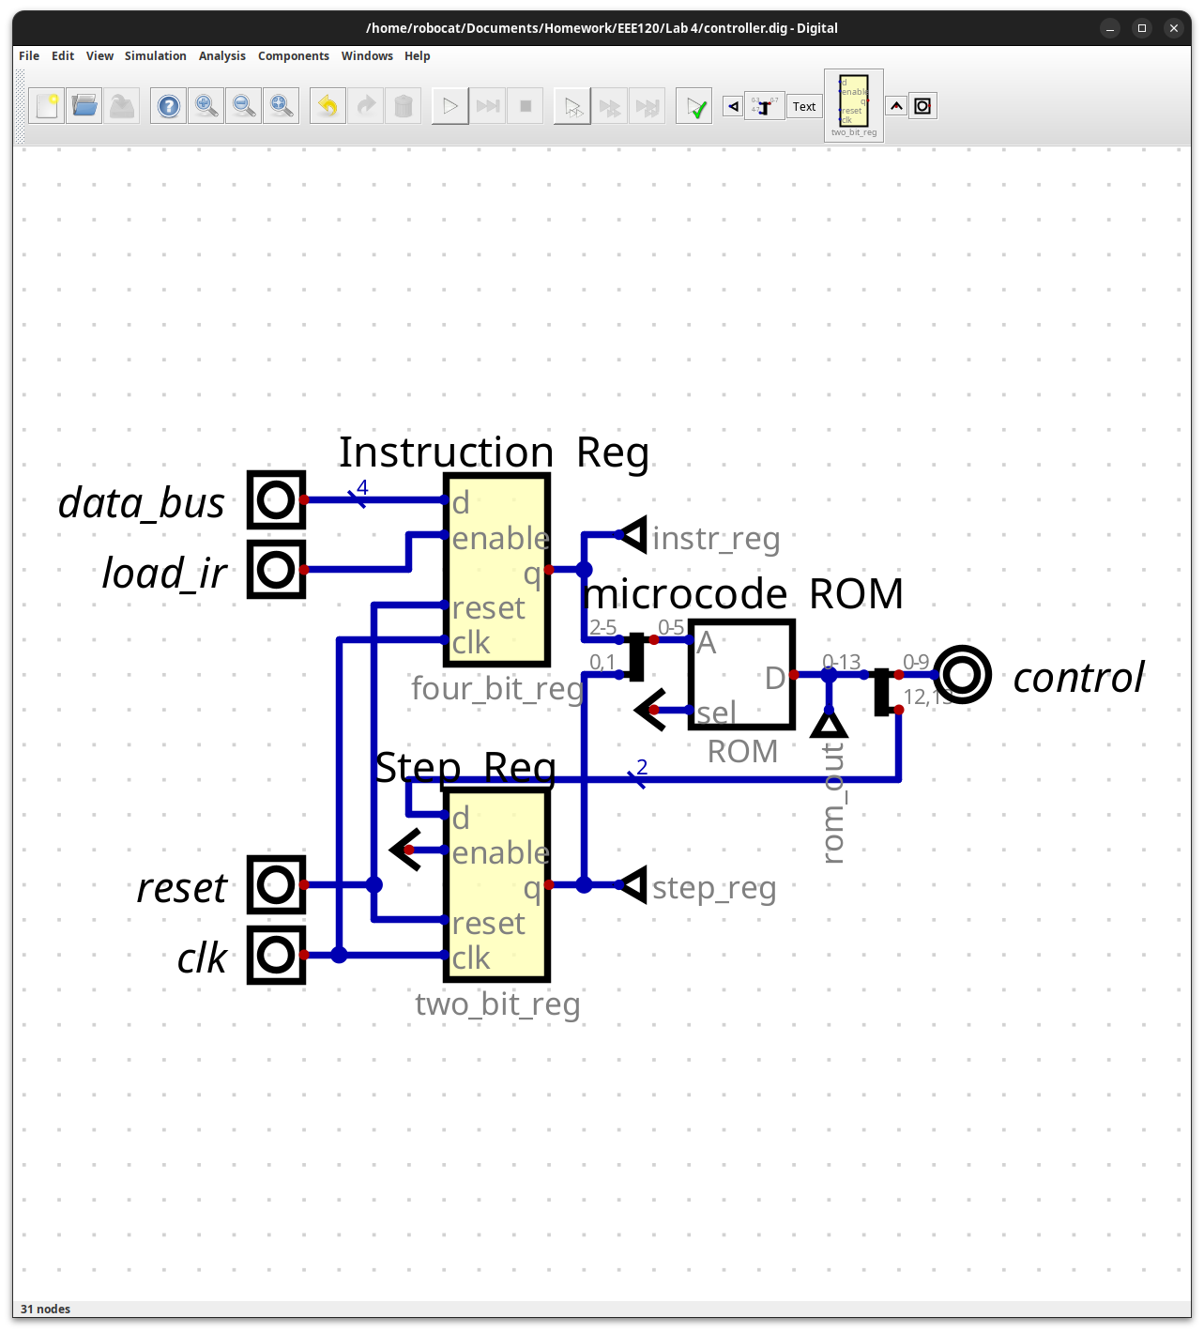
Please comment on the single biggest issue you were facing when designing the circuit.
It was hard to find the picture of what to build in the instructions.
Did the circuit behave as expected? If no, what was wrong?
Yes the circuit behaved as I expected it too.
Please comment on the single biggest issue you were facing when simulating the circuit.
It was hard to know what the intended behavior for some input is, so fully testing the circuit is hard.
Task 4-3: Build the Complete Microprocessor Circuit
Include a picture of your Digital circuit here (make sure to show final values as shown in figure 17):
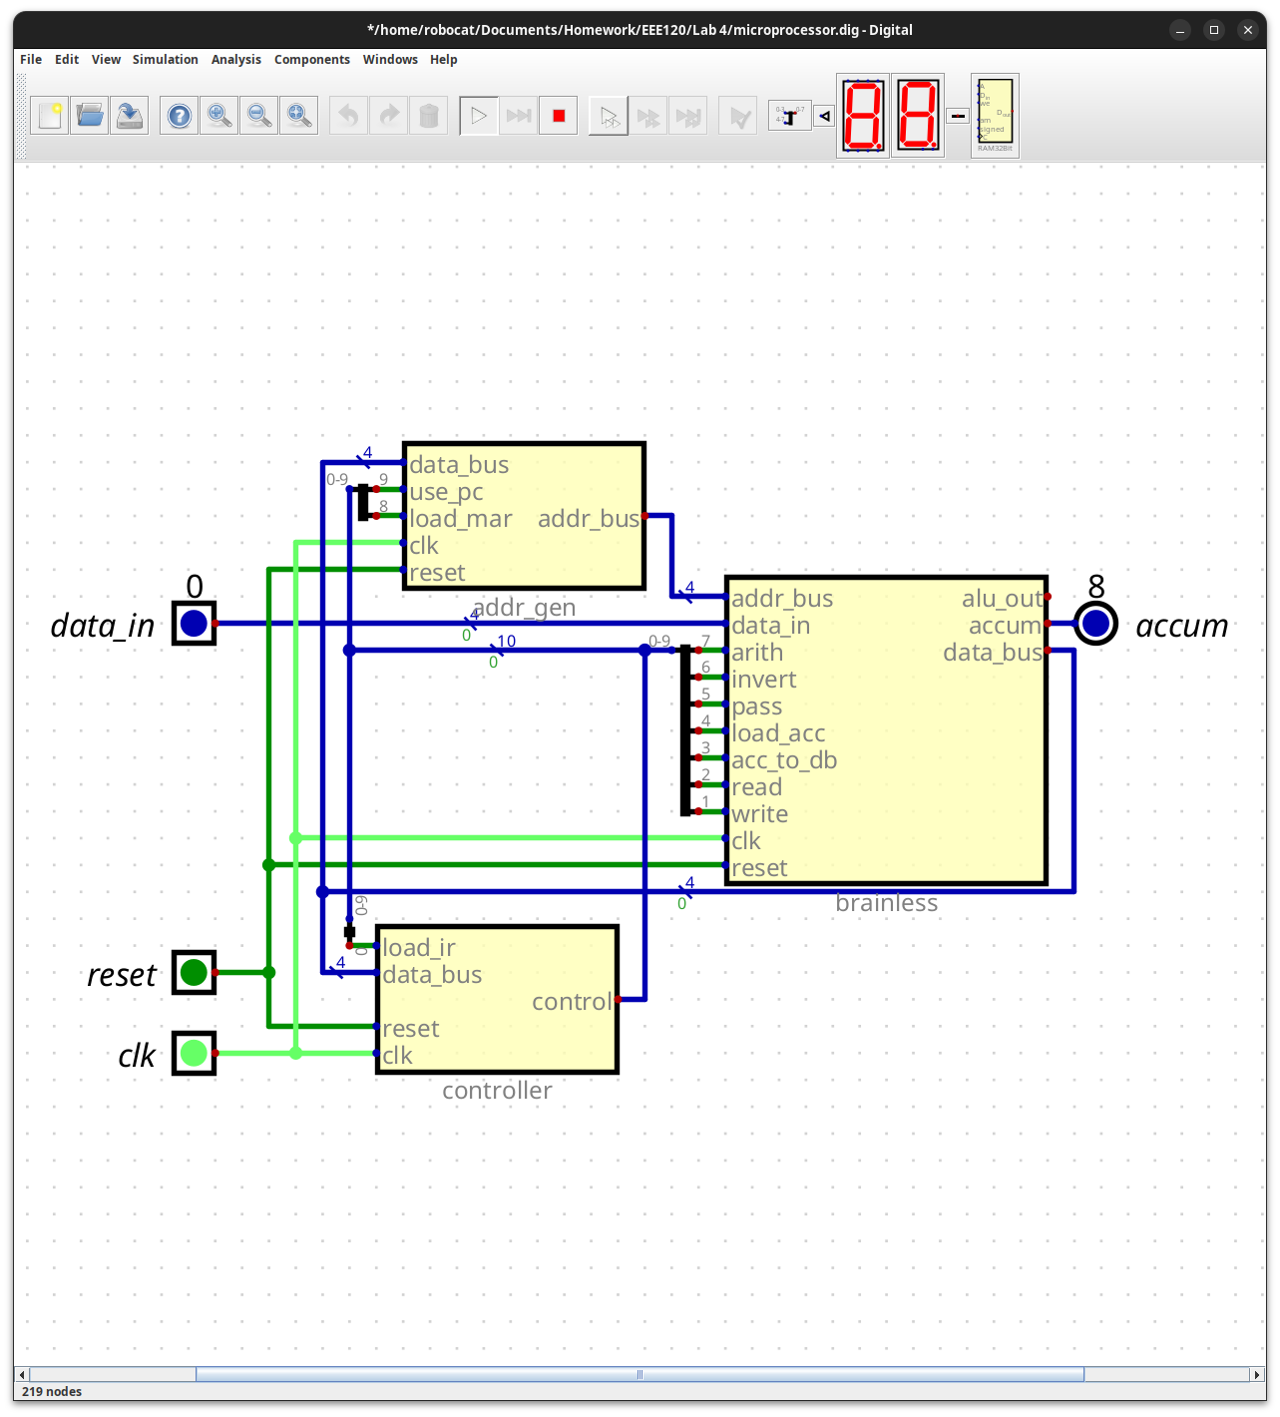
Please comment on the single biggest issue you were facing when designing the circuit.
Getting the splitters to work as I wanted them too.
Did the circuit behave as expected? If no, what was wrong?
Yes, the circuit behaved as expected.
Please comment on the single biggest issue you were facing when simulating the circuit.
For some reason, the small number that states a wire’s value was not working for the addr_bus wire, so to test it, I had to use the 7 segment display.
Task 4-4: Simulate the Design in Verilog
Include a picture of your waveforms here:
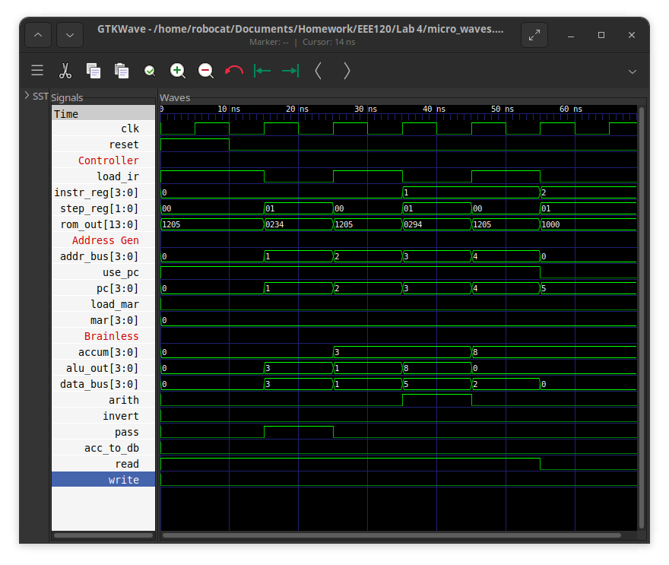
Please comment on the single biggest issue you were facing when simulating the processor.
I forgot to replace the # comments with //, leading to my waveform having lots of red x’s.+

Did the circuit behave as expected? If no, what was wrong?
Yes, the circuit worked as I expected.
Please comment on the single biggest issue you were facing when simulating the circuit.
I did not realize that Digital will not automatically update the ROM like how it updates the RAM, and I had to go in and update it.

Task 4-5: Add the AND, ZERO, SUB, and STORE ACC Instructions
Paste the contents of your final rom_vals here:
v2.0 raw
1205 # LOAD ACC; Load IR
0234 # Load ACC
0000 # unused
0000 # unused
1205 # ADD ACC; Load IR
0294 # ADD
0000 # unused
0000 # unused
1205 # STOP; Load IR
1000 # stay here
0000 # unused
0000 # unused
1205 # AND; Load IR
0214 # AND
0000
0000
1205 # ZERO; Load IR
00D8 # ACC - ACC
0000
0000
1205 # SUB; Load IR
02D4 # SUB
0000
0000
1205 # STORE ACC; Load IR
2304 # Set the MAR to the address
010A # Store var
0000
1205 # Extra Credit; Load IR -- Store Data_in in accum
0030 # Save value
0000
3FFF

Test your instructions by writing and executing programs. Paste the contents of your ram_vals.txt file for each program. Note which instruction or instructions each program tests. (It is fine to combine the stimulus so fewer waveforms are needed. Make sure you indicate which instructions are included in each waveform!)
Include a picture of your AND waveforms here:
Include a picture of your ZERO waveforms here:
Include a picture of your SUB waveforms here:
Include a picture of your STORE ACC waveforms here:
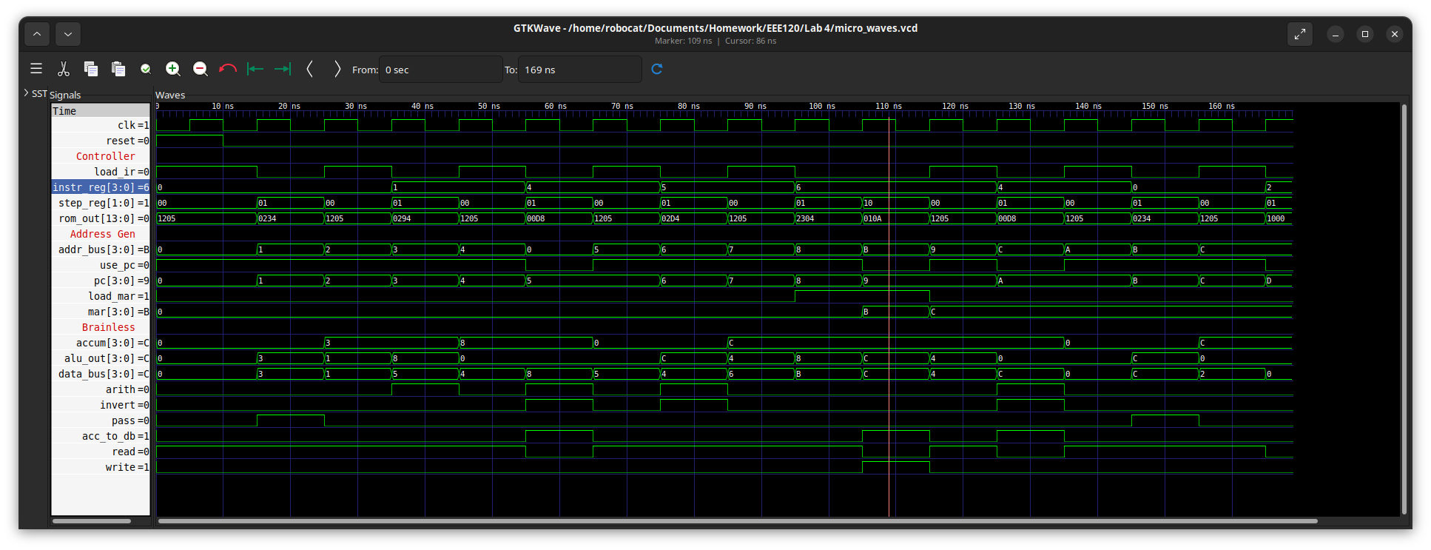
0// Load ACC
3// value to load
1// ADD ACC
5// value to add
//After 4 clocks (40-50ms), accum = 0x8
4 //ZERO
//Two clocks later (60-70ms) accum = 0x0
5//Subtract
4// value to subtract
//After 2 more clocks (80-90ms) accum = -4 = 0xC
6//Store that value in a the param of the next command
B //Address of the `F` below
//After 3 more clocks (110-120ms) mem adress 0xB is now a C
4 //Zero the accum in middle, to show it clears.
//Two clocks later (130-140ms) accum = 0x0
0 // Move the output of the storage command to the acc
F // THIS WILL BE REPLACED BY THE STORAGE COMMAND
//Two clocks later (150-150ms) accum = 0xC
//should be 0xC if set worked, 0xF if failed.
2// STOP
Did the circuit behave as expected? If no, what was wrong?
Yes, the circuit behaves as expected
Please comment on the single biggest issue you were facing when simulating the circuit.
I struggled to think of the order to have the commands to best showcase all the commands.
Task 4-6: Invent Your Own Instruction (Extra Credit)
Place the contents of the rom_vals for the extra credit instruction here:
1205 # Extra Credit; Load IR -- Store Data_in in accum
0030 # Save value
0000
3FFF
Include your Verilog ram_vals.text program used to test the extra credit instruction here:
7 // Store the data on the data bus in accum.
7 // Store the data on the data bus in accum.
7 // Store the data on the data bus in accum.
2 //STOP
test_vals[ 0] = 12'h0_1_0; // reset - this should always be the first vector
test_vals[ 1] = 12'h0_0_0;
test_vals[ 2] = 12'h2_0_2;
test_vals[ 3] = 12'h2_0_2;
test_vals[ 4] = 12'hE_0_E;
test_vals[ 5] = 12'hE_0_E;
test_vals[ 6] = 12'hA_0_A;
test_vals[ 7] = 12'hA_0_A;
test_vals[ 8] = 12'hA_8_A;
Include a picture of your waveforms here:
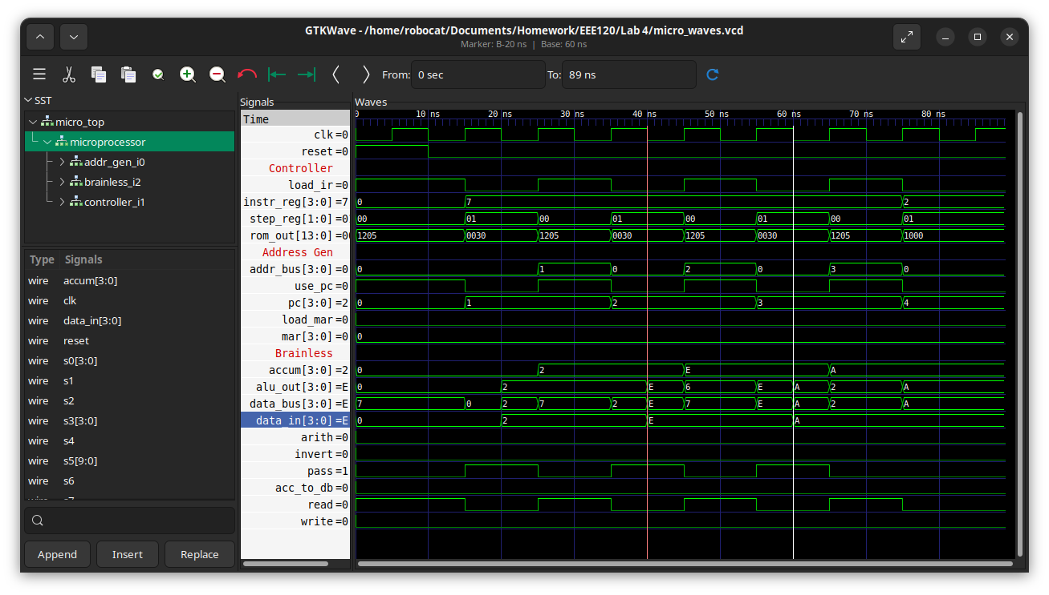
Include a picture of your ROM contents here:
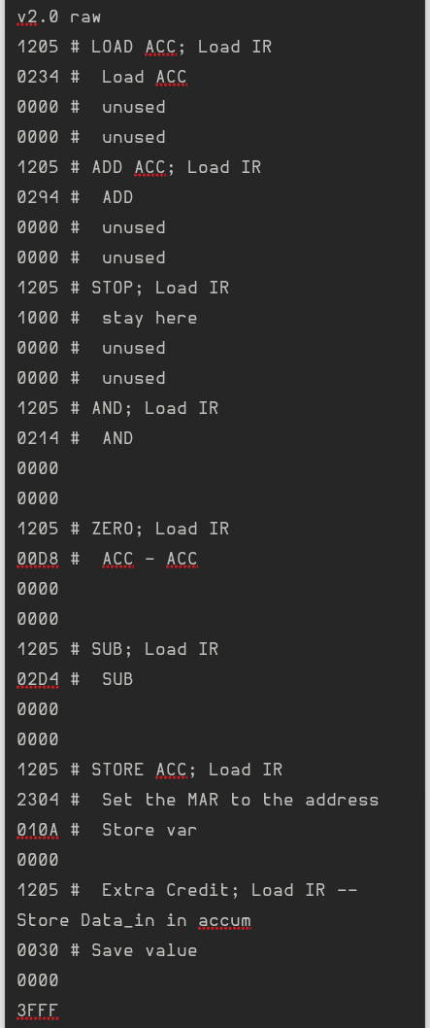
Task 4-7: Create a video and submit your report
Record a short video showing your schematics in Digital and your waveforms in GTKWave. Be sure to show yourself in the video and show your screen. Explain how your circuit works – you need to convince the grader you did the lab and understand it! Copy and paste the link to your video below. Make sure the link is working and pointing to the correct video. Remember to include the password if required. Do NOT upload your video to Canvas. It is recommended that you use Zoom to record to the cloud, pasting the link and password below. If your circuit is not working as expected, explain in the video how it is not working and why you think it is not working.
Video Link: https://drive.google.com/file/d/1Qu1LxkyO8kF20DNQaF-QC-lxZt6VcfVj/view?usp=drive_link
At the beginning of your recording, say your name and the lab name. Be brief in your recording. Submit the completed template to Canvas.
Make sure all your files are in the Lab2 directory. Create a zip file of the Lab2 directory. Remember to turn in the zip file and your completed template on Canvas!
Do not include the video in the zip file! This makes the file very large and you run the risk of the zip file not uploading or taking so long to upload that your submission will be late. Remember that the submission is dated at the time the upload completes, not when it starts!

Lab 4: Lab Report Grade Sheet

Name:

NOTE: You submit the zip file in order to show your work.
If the zip file is not submitted you will receive a 0 for this lab!

Instructor Assessment
Grading Criteria | Max Points | Points Lost
Description of Assigned Tasks, Work Performed & Outcomes Met
Task 4-1: Build and Test the Memory-Address-Generation Circuit | 10
Task 4-2: Build and Test the Controller Circuit | 10
Task 4-3: Build the Complete Microprocessor Circuit | 10
Task 4-4: Write and Execute a Simple Program for Your Microprocessor in Simulation | 10
Task 4-5: Add the ‘AND’, ‘Zero’, ‘Subtract’, and ‘Store ACC’ Instructions | 30
Task 4-6: Invent Your Own Instruction (Extra Credit) | 10
Task 4-7: Record your video | 10
 | Points Lost
Lab Score (80 points total) | Late Lab
 | Lab Score

